**Lesson 4. Email Basics.**



**Lead-in. Discuss with a partner.**

1. How often do you use emails?
2. What’s usually the purpose of your emails?
3. When do you choose email instead of instant messaging on Skype, face-to-face communication, telephoning?

**Task 1.** [**Listen**](http://www.talkenglish.com/lessondetails.aspx?ALID=462) **to the recording. Write down the 3 ways of how to ask someone for an email address (0:00-0:29).**

________________________________________________________________________________________________

* Write down your email address and [spell](https://dictionary.cambridge.org/dictionary/english/spell) it to your partner. _____________________________________________

**Task 2 A. Read the email below. Name the parts of the email.**

Hello Mr. Roger Jones:

I got the letter you sent on 1st September, and the stuff about the stock control system you make. It sounds great for us, but I want to check some things before we buy it. You said the system is bang up-to-date, but what happens if you update it again soon? Do we get money off the new one? You said it takes 3 weeks to install the system - that’s too long! Can’t you do it any quicker?

Hope you can reply soon, we’re in a bit of a hurry.

Thanks,

Janet Brown,

**Task 2 B. Match the email components with the paragraphs in the email above.**



greeting ____

the signature ____

closing ____ ____

the body of the email ____

**Task 3 A. Look at the email in Task 2 A again and answer the questions.**

1. Have the sender and the receiver been in contact before?
2. What are the problems with the system?
3. Is the style of the email appropriate? Why/Why not?

**Task 3 B. In pairs, make changes in the email (Task 2 A) to make it more appropriate as a formal email.**

**Task 3 C. Look at the model email, put the paragraphs in the correct order, and compare the email with yours.**

Yours sincerely,

Ms J. Brown

Thank you in advance for your assistance. I look forward to your reply.

Secondly, the installation and implementation period of three weeks, to which you refer in your letter, seems rather long. Is there any possibility of getting the system up and running on a shorter timescale?

I would be very grateful for a swift response to these queries, in order that we can begin the process as soon as possible.

Firstly, although you mentioned that the system has recently been updated, I wondered whether we might be eligible for a discount on any future upgrades.

**Task 3 D. Underline the language in Task 3 C that you could use to improve your letter.**

I would be very grateful for a swift response to these queries, in order that we can begin the process as soon as possible.

Dear Mr. Jones,

Thank you for your letter of 1st September and the information you sent regarding the stock control system offered by your company. I certainly feel the system will meet our requirements. However, there are some points that I would like to clarify before we go ahead and order the system.

**Task 4. Watch** [**video 1**](https://drive.google.com/file/d/17Zw_NRXxr0TcSdoBK93cbt0_DDo0N-2O/view?usp=sharing) **about best practices for email, and mark the statements below as true (T) or false (F). Compare your answers with a partner.**

1. It’s not always necessary to give your message a subject heading. ____
2. Don't write in all CAPS (capital letters). ____
3. You can write in all lowercase letters if it is a very informal letter. ____
4. It’s a good idea to start each sentence on a new line. ____
5. Don’t write a long text as one paragraph. ____
6. The subject heading should be concise. ____
7. Change the subject heading for the same thread. ____
8. Use line breaks between paragraphs. ____
9. Use punctuation. ____
10. If you have time, check for mistakes before you send your message. ____

**Task 5. Read the task. Underline the key phrases. Identify the style: formal or informal.**

You are organizing a conference for EPAM. You have already booked the Hilton hotel where the conference will be held and have just received a letter of confirmation. However, you need to make some changes to the arrangements.

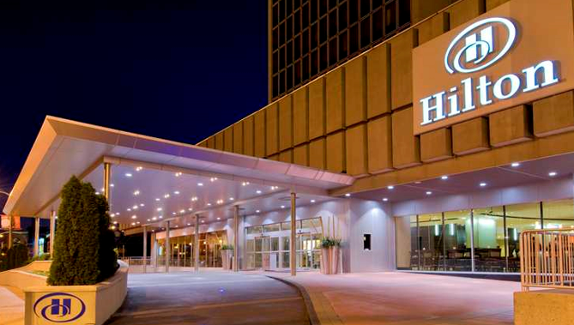

Write a letter to the hotel manager. You **must:**

* inform that you received the confirmation
* ask to change the date
* apologize for the reschedule

**Write about 50-60 words**.

___________________________________________________________________________________________________________________________________________________________________________________________________________________________________________________________________________________________________________________________________________________________________________________________________________________________________________________________________________________________________________________________________________________________________________________________________________________________________________________________________________________________________________________________________________________________________________________________________________________________________________________________________________________________________________________________________________________________________________________________________________________________________________________________________________________________________________________________________________________________________________________________________________________________________________________________________________________________________________________________________________________________________________________________________________________________________________________________________________________________________________________________________________________________________________________________________________________________________________________________________________________________________________________________________________________________________________________________________________________________________________________________________________________________________________________